Student worksheet

5.1 Physical change is a change in shape or appearance

Pages 80–81 and 189–190

Physical changes

1 What is a physical change?

2 Give an example of a physical change and explain why it is a physical change.

3 What happens to the molecules in water when they change state from a liquid to a gas?

4 What happens to the molecules in water when they change state from a gas to a liquid?

5 Explain why boiling water is a physical change.

6 Match the following words to their meanings.

|  |  |  |
| --- | --- | --- |
| 1 Vapour |  | A Substances that vaporise easily |
| 2 Boil |  | B Three-dimensional arrangement of particles in a regular pattern |
| 3 Condense |  | C Gaseous form of a substance |
| 4 Fumes |  | D When you cool a gas to become a liquid |
| 5 Vaporise |  | E Occurs when you heat a liquid to become a gas |
| 6 Lattice |  | F Vapours that are smelly |
| 7 Volatile |  | G When you heat a solid to become a liquid |
| 8 Melting |  | H Liquid evaporates to become a gas |
| 9 Sublimation |  | I When you heat a solid and it becomes a gas rather than a liquid |

7 Label the following diagram with the correct terminology to illustrate a change in state of water.

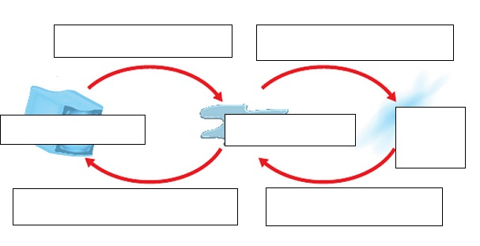

8 Explain the difference between melting and sublimation.

9 Explain the difference between solidification and freezing.

Extend your understanding

10 Provide four examples of physical changes in your home and explain why each one is considered to be a physical change.

Student worksheet

5.2 Chemical change produces new substances

Pages 82–83 and 190–191

Chemical changes

1 What is a chemical change?

2 Use the following diagram to explain the difference between a chemical and physical change

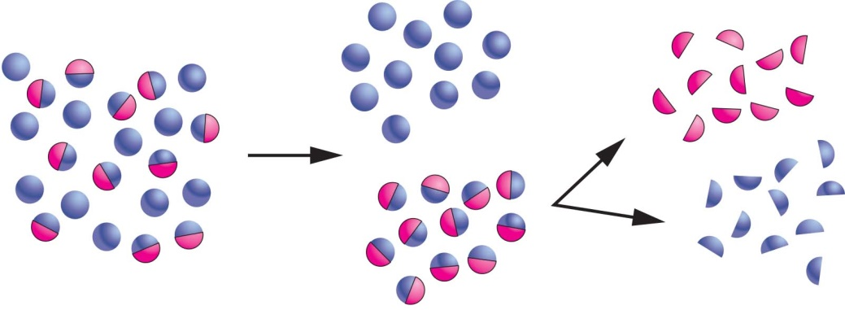

3 What are four signs that you would look for to know that a chemical change has occurred?

4 Explain why heating chocolate can be both a chemical and physical change.

5 What would you look for to know that melted chocolate has undergone a chemical rather than a physical change?

6 Explain why each of the following examples are, or could be, chemical changes.

|  |  |
| --- | --- |
| SW0504_00951-rm |  |
| SW0505_00951-rm |  |
| **SW0506_00951-rm** |  |
| SW0507_00951-rm |  |

|  |  |
| --- | --- |
| SW0508_00951-r |  |

Extend your understanding

7 Are the following pictures examples of chemical or physical changes?

|  |  |  |  |
| --- | --- | --- | --- |
| SW0509_00951 | SW0510_00951  \_\_\_\_\_ | SW0511_00951 | SW0512_00951 |
| SW0513_00951 | SW0514_00951 | SW0515_00951 | SW0516_00951 |

Student worksheet

5.3 Chemical reactions can break bonds and re-form new bonds

Pages 84–85 and 192

Chemical reactions

1 What is a chemical reactant?

2 What is a chemical product?

3 On which side of a chemical reaction arrow do products and reactants belong?

4 Write a worded chemical equation for the following chemical reactions, and label the reactants and products (using the second line).

a Oxygen and hydrogen react to form water

b Iron and oxygen will form iron oxide

c Peroxide will break down (decompose) into water and oxygen

d Water and carbon dioxide react in the leaves of plants to form glucose (a sugar) and oxygen

e Petrol, in a car, will burn in the presence of oxygen to form carbon dioxide and water

5 What is a combustion reaction?

6 Write a worded equation for the combustion of magnesium.

7 The products of the combustion of hydrocarbons are carbon dioxide and water. Write worded equations for the following reactions and label the reactants and the products (using the second line).

a combustion of ethene

b combustion of octane

Extend your understanding

Polymerisation is the process of joining many small molecules (monomers) together to make one very large molecule (polymer). Plant cell walls, for example, are made out of cellulose. Cellulose is a large polymer made up of many glucose monomers. This polymerisation process is called condensation polymerisation.

8 What does the suffix ‘mono’ mean in the word ‘monomer’?

9 What does the suffix ‘poly’ mean in the word ‘polymer’?

10 Research and draw the structure of glucose, showing all the bonds between atoms.

11 What does condensation mean?

12 What would be the products of a condensation polymerisation reaction?

Student worksheet

5.4 Heat can speed up a reaction

Pages 86–87 and 193–194

The effect of heat on the speed of reactions

1 How does particle size affect the rate of a chemical reaction?

2 Which of the following diagrams will have a faster rate of reaction? Explain your answer.

a 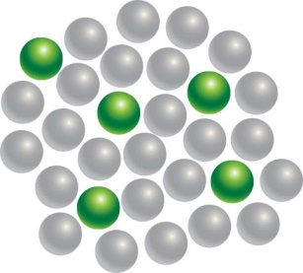 b 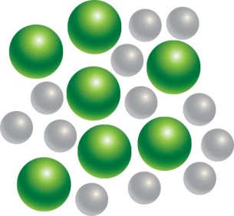

3 What must happen in order for chemicals to react? (Hint: collision theory)

4 How does temperature increase the rate of a reaction?

5 What type of energy does temperature give to particles?

6 What is the definition of this type of energy?

7 What is concentration?

8 How does concentration affect the rate of a reaction?

9 Which of the following diagrams will have a faster rate of reaction? Explain your answer.

a 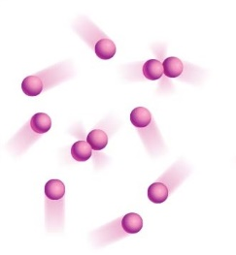 b 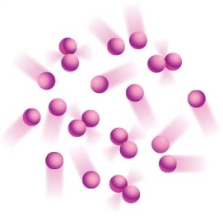

10 What is a catalyst?

11 How does a catalyst affect the rate of a chemical reaction?

12 Why are enzymes ‘fussy’?

Extend your understanding

13 Travis and Jack perform two chemical reactions under different conditions. Travis wants to react different concentrations of hydrochloric acid with magnesium metal. Jack wants to see whether increasing the temperature of a reaction will make it go faster. The reactions they used are shown below.

|  |  |  |  |  |
| --- | --- | --- | --- | --- |
| Jack | |  | Travis | |
| **Beaker 1** | **Beaker 2** |  | **Beaker 1** | **Beaker 2** |
| Dilute hydrochloric acid + 1 g of magnesium ribbon  at 20ºC | Concentrated hydrochloric acid +  1 g of magnesium ribbon at 20º C |  | Concentrated hydrochloric acid +  1 g of magnesium ribbon at 20º C | Concentrated hydrochloric acid +  1 g of magnesium ribbon at 60º C |

a What is Jack’s hypothesis?

b What is Travis’s hypothesis?

c What will be Jack’s results? Explain why.

d What will be Travis’ results? Explain why.

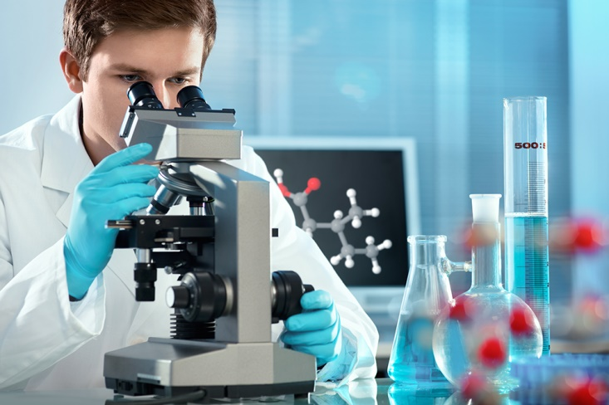Student worksheet

5.5 Many substances exist because of the work of scientists

Pages 88–89 and 195

Chemical substances

1 What is the role of a chemist in a pharmacy?

2 What is a chemist who works in a pharmacy called?

3 Explain the process of oil being extracted from the ground and turned into petroleum.

4 What high-value materials is crude oil converted into?

5 What can plastics be used for?

6 When and where was the first documented case of glue?

7 What was glue first used for?

8 From what sources can glues be extracted?

9 What is the difference between natural and synthetic glue?

10 What was the first dye obtained from?

11 How was the colour purple or ‘mauve’ discovered? Who discovered it and when did they do so?

12 What is an advantage of modern inks over earlier ones?

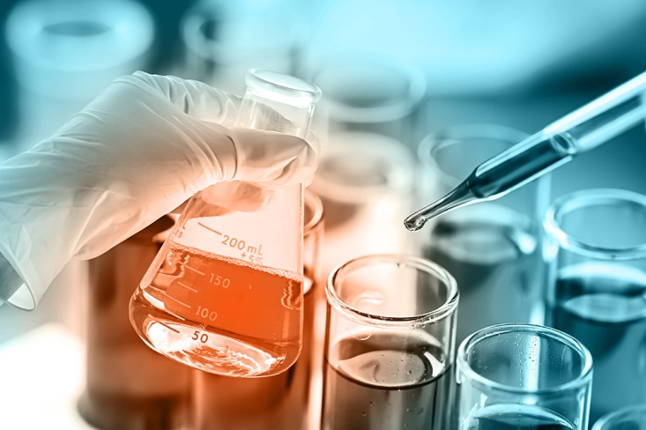Extend your understanding

There are many different types of chemists who perform many different analyses on materials for many different purposes. Match the following chemical areas to the analyses that they perform.

|  |  |  |
| --- | --- | --- |
| *Organic chemistry* | *Analytical chemistry* | *Industrial chemistry* |
|  |  |  |
| *Food chemistry* | *Environmental chemistry* | *Forensic chemistry* |
|  |  |  |
| *Pharmaceutical chemistry* |  |  |

13 What kind of chemistry is required to:

a perform DNA analysis?

b create pharmaceutical drugs?

c work in a mining smelter?

d determine the chemical makeup of unknown chemical samples?

e extract biomolecules from seaweed and determine their function?

f analyse smog to determine its impact on the environment?

g taste test ice-cream to ensure it has the correct composition of flavours?

Student worksheet

5.6 Physical and chemical changes are used to recycle household waste

Pages 90–91

Recycling

1 How many groups are plastics classified into?

2 The steps below for the mechanical/physical recycling of plastics are out of order. Write the correct number next to its corresponding description.

|  |  |
| --- | --- |
| Step Number | Description of the process |
|  | Floating off the plastics according to their density |
|  | Cooling the strands and cutting it into small pellets so that it can be reused for new products |
|  | Extruding the plastic by heating it to a melting state and forcing it into long strands |
|  | Cutting the large pieces of plastic using shears or saws |
|  | Separating the contaminants in cyclone (centrifuge) separators |
|  | Shredding the plastic into small flakes |

3 What does the chemical recycling of plastics involve?

4 How can metals be recycled?

5 What is corrosion? Give an example with a worded chemical equation.

6 Why is corrosion a problem in recycling?

7 Match each of the plastics symbols below with the correct description.

|  |  |  |
| --- | --- | --- |
| SYMBOL |  | DESCRIPTION |
|  |  | A Polyvinyl chloride (PVC) is used to make clear food packaging, shampoo and medication bottles, and food trays |
|  |  | B Polypropylene (PP) is used to make microwave meal trays, sauce bottles, yoghurt containers and medicine bottles |
|  |  | C Polyethylene terephthalate (PET or PETE) is the plastic found in soft drink bottles or oven ready meal trays |
|  |  | D Contains all other plastics, including nylon and fibreglass that cannot be recycled |
|  |  | E Polystyrene (PS) is used to make foam meat or fish trays, coffee cups, plastic cutlery and sandwich boxes |
|  |  | F High density polyethylene (HDPE) is used to make milk and juice bottles, some washing-up bottles, toys and grocery bags |
|  |  | G Low density polyethylene (LDPE) is used to make grocery bags, bin liners, bread bags and frozen food bags |

Extend your understanding

8 Which of the plastics in question 7 can be recycled by your curbside rubbish collection? Which cannot?

9 Many people do not understand which plastics are which, how to tell the difference, or which ones can be recycled. Create a mini-poster in the space below to educate them.